**Pleasant Tours**

|  |  |  |  |
| --- | --- | --- | --- |
| Supervisor: | | Abdul Ahad | |
| Batch: | | 2209E | |
| Group: | | Pleasant Tours | |
| Serial No. | Enrollment No. | | Student Name |
| 1. | 1413931 | | Mohammad Shayan |
| 2. | 1413916 | | Hafiz Muhammad Shuais |
| 3. | 1413909 | | Asghar Abbas |
| 4. | 1413911 | | Syed Kashan Abbas Naqvi |
| 5. | 1416016 | | Abdullah |

**Acknowledgement**

The first, we would like to express my special thanks of gratitude to my teacher SIR ABDUL AHAD who helped a lot in finalizing this project within the limited time frame, valuable counseling and assistance for the accomplishment of this project. Secondly, we would also like to thanks the e-project team at Aptech Head Office, who gave as the opportunity to do this interesting and wonderful project about Pleasant Tours

Thirdly, we also thank the e-project team for giving this task to us. Following are the benefits of this Project:

* Re-enforcement of skills happens in the experimental learning process.
* A mentor, ensuring that we do not get drifted, constantly guide us.
* It gives us a lot of confidence to face an interview as we have worked on a project. We can explain virtually everything on the subject we have learnt.

**Synopsis:**

Pleasant Tours is a very important feature used in e-commerce to assist people making purchases online, similar to the US English term ‘ordering cart’. The business to customer aspect of electronic commerce (e-commerce) is the most visible business use the World Wide Web. The synopsis of online Tourism Product Shop is to develop a general purpose e-commerce store where any Tourism Product can be bought from the comfort of home .

The Pleasant Tour is a virtual store on the internet where customer can browser the catalogue and select products of interest. This project has been develop to allow business grow larger and faster. Customer is the user of the system. When the user type in the URL of the website, a home page shown. The user will go to the Contact, Products, Login/SignUp from the home page.

**Site Map:**

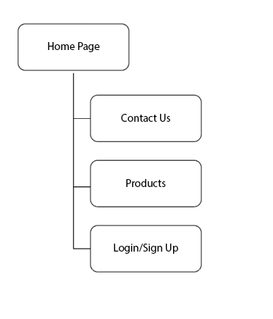

|  |  |  |  |
| --- | --- | --- | --- |
| Project: Pleasant Tours | | Date of preparation of activity plan | |
| No. | Task | | Team-Mate Name |
| 01. | Home Page | | Shayan |
| 02. | Product Page | | Kashan, Abdullah |
| 03. | Contact Page | | Asghar, Shayan |
| 04. | Login/Sign Up | | Shuais, Shayan |
| 05. | Documentation | | Shayan |

|  |  |
| --- | --- |
| Actual Start Date | Actual Days |
| 14-Dec-2022 | 20 Days |